Para los diseños muestrales siguientes  calcula la matriz de diseño.

1.- U={1,2,3,4}; d: P((1))=0.1, P((1,2))=0.2, P((1,2,3)=0.3, P((1,2,3,4))=0.4.

En primer lugar obtenemos las probabilidades de inclusión del primer orden, según la definición 3.13:

product for 1 of equals straight P left parenthesis left parenthesis 1 right parenthesis right parenthesis plus straight P left parenthesis left parenthesis 1 comma 2 right parenthesis right parenthesis plus space straight P left parenthesis left parenthesis 1 comma 2 comma 3 right parenthesis plus straight P left parenthesis left parenthesis 1 comma 2 comma 3 comma 4 right parenthesis equals 0.1 plus space 0.2 plus 0.3 space plus 0.4 equals space 1

product for 2 of equals straight P left parenthesis left parenthesis 1 comma 2 right parenthesis right parenthesis plus space straight P left parenthesis left parenthesis 1 comma 2 comma 3 right parenthesis plus straight P left parenthesis left parenthesis 1 comma 2 comma 3 comma 4 right parenthesis equals 0.2 plus 0.3 space plus 0.4 equals space space space 0.9

product for 3 of equals straight P left parenthesis left parenthesis 1 comma 2 comma 3 right parenthesis plus straight P left parenthesis left parenthesis 1 comma 2 comma 3 comma 4 right parenthesis equals 0.3 space plus 0.4 equals space space space 0.7

product for 4 of equals straight P left parenthesis left parenthesis 1 comma 2 comma 3 comma 4 right parenthesis equals 0.4 equals space space space 0.7

Luego obtenemos las probabilidades de inclusión de segundo orden, según la definición 3.14:

product for 12 of equals straight P left parenthesis left parenthesis 1 comma 2 right parenthesis right parenthesis plus space straight P left parenthesis left parenthesis 1 comma 2 comma 3 right parenthesis right parenthesis plus straight P left parenthesis left parenthesis 1 comma 2 comma 3 comma 4 right parenthesis right parenthesis equals 0.2 plus 0.3 space plus 0.4 equals space 0.9
stack product subscript 13 with blank below equals space straight P left parenthesis left parenthesis 1 comma 2 comma 3 right parenthesis right parenthesis plus straight P left parenthesis left parenthesis 1 comma 2 comma 3 comma 4 right parenthesis right parenthesis equals space 0.3 space plus 0.4 equals space 0.7
stack product subscript 14 with blank below equals space straight P left parenthesis left parenthesis 1 comma 2 comma 3 comma 4 right parenthesis right parenthesis equals space 0.4
stack product subscript 23 with blank below equals space straight P left parenthesis left parenthesis 1 comma 2 comma 3 right parenthesis right parenthesis plus straight P left parenthesis left parenthesis 1 comma 2 comma 3 comma 4 right parenthesis right parenthesis equals space 0.3 space plus 0.4 equals space 0.7
stack product subscript 24 with blank below equals space straight P left parenthesis left parenthesis 1 comma 2 comma 3 comma 4 right parenthesis right parenthesis equals space 0.4
stack product subscript 34 with blank below equals space straight P left parenthesis left parenthesis 1 comma 2 comma 3 comma 4 right parenthesis right parenthesis equals space 0.4


De esta forma, la matriz de diseño, quedaría definida así:

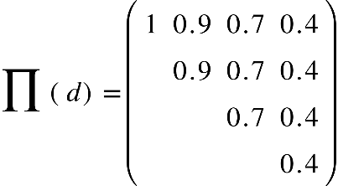

2.- U={1,2,3,4}; d:  P((1))=0.1, P((2))=0.2=P((3)), P((4))=0.3, P((1,2,3,4))=0.2.

En primer lugar obtenemos las probabilidades de inclusión del primer orden, según la definición 3.13:

product for 1 of equals straight P left parenthesis left parenthesis 1 right parenthesis right parenthesis plus straight P left parenthesis left parenthesis 1 comma 2 comma 3 comma 4 right parenthesis right parenthesis equals space 0.1 plus space 0.2 space equals space 0.3

product for 2 of equals straight P left parenthesis left parenthesis 2 right parenthesis right parenthesis plus space straight P left parenthesis left parenthesis 1 comma 2 comma 3 comma 4 right parenthesis right parenthesis equals space 0.2 space plus space 0.2 space equals space 0.4

product for 3 of equals straight P left parenthesis left parenthesis 3 right parenthesis right parenthesis plus space straight P left parenthesis left parenthesis 1 comma 2 comma 3 comma 4 right parenthesis right parenthesis equals space 0.2 space plus space 0.2 space equals space space space 0.4

product for 4 of equals straight P left parenthesis left parenthesis 4 right parenthesis right parenthesis plus straight P left parenthesis left parenthesis 1 comma 2 comma 3 comma 4 right parenthesis right parenthesis equals 0.5

Luego obtenemos las probabilidades de inclusión de segundo orden, según la definición 3.14:

product for 12 of equals space product for 13 of equals space product for 14 of equals product for 23 of equals product for 24 of equals product for 34 of space equals space 0.2


De esta forma, la matriz de diseño, quedaría definida así:

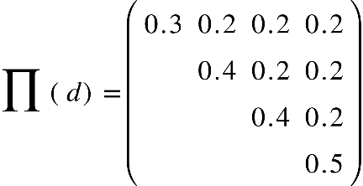

3.-U={1,2,3,4,5,6,7,8}; d:  P((1,2,3))=0.4, P((4,5,6))=0.3, P((7,8))=0.3.

En primer lugar obtenemos las probabilidades de inclusión del primer orden, según la definición 3.13:

product for 1 of equals space product for 2 of equals space product for 3 of equals 0.4
stack product subscript 4 with blank below equals space product for 5 of equals space product for 6 of equals 0.3
product for 7 of equals space product for 8 of equals 0.3

Luego obtenemos las probabilidades de inclusión de segundo orden, según la definición 3.14:

product for 12 of equals product for 13 of equals 0.4
stack product subscript 14 with blank below equals space product for 15 of equals space... space equals product for 18 of equals 0

product for 23 of equals 0.4
stack product subscript 24 with blank below equals space product for 25 of equals space... space equals product for 28 of equals 0

stack product subscript 34 with blank below equals space product for 35 of equals space... space equals product for 38 of equals 0

product for 45 of equals product for 46 of equals 0.3
stack product subscript 47 with blank below equals space product for 48 of equals 0

product for 56 of equals 0.3
stack product subscript 57 with blank below equals space product for 58 of equals 0

stack product subscript 67 with blank below equals space product for 68 of equals 0

stack product subscript 78 with blank below equals 0.3

De esta forma, la matriz de diseño, quedaría definida así:

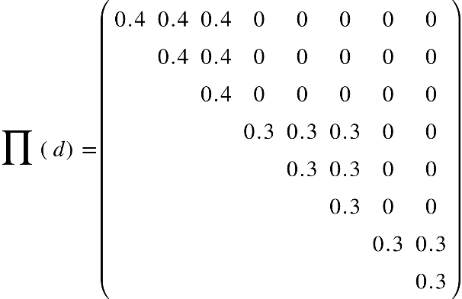

4.- U={1,2,...,N}; d:  P((i))=p si 1 <= i <= N, P(1,2,...,N))=1-Np, con  0<p<1/N

En primer lugar obtenemos las probabilidades de inclusión del primer orden, según la definición 3.13:

product for 1 of equals straight P left parenthesis left parenthesis 1 right parenthesis right parenthesis plus straight P left parenthesis left parenthesis 1 comma 2 comma.. comma N right parenthesis right parenthesis equals space p plus space open parentheses 1 minus N subscript p close parentheses space equals space p open parentheses 1 minus N close parentheses plus 1

product for 2 of equals straight P left parenthesis left parenthesis 2 right parenthesis right parenthesis plus straight P left parenthesis left parenthesis 1 comma 2 comma.. comma N right parenthesis right parenthesis equals space p plus space open parentheses 1 minus N subscript p close parentheses space equals space p open parentheses 1 minus N close parentheses plus 1

...

product for N of equals straight P left parenthesis left parenthesis N right parenthesis right parenthesis plus straight P left parenthesis left parenthesis 1 comma 2 comma.. comma N right parenthesis right parenthesis equals space p plus space open parentheses 1 minus N subscript p close parentheses space equals space p open parentheses 1 minus N close parentheses plus 1


Luego obtenemos las probabilidades de inclusión de segundo orden, según la definición 3.14:

dado que,

P open parentheses 1 comma 2 comma... comma N close parentheses equals 1 minus N subscript p

tenemos,

stack product subscript 12 with blank below equals space product for 13 of equals space... space equals product for N open parentheses N minus 1 close parentheses of equals product for N N of equals 1 minus N subscript p

De esta forma, la matriz de diseño, quedaría definida así:

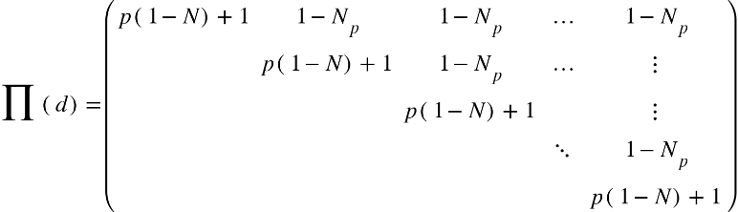

 5.- U={1,2,...,N}; d:  P((1,2))=p_{1}, P((2,3))=p_{2},..., P((N-1,N))=p_{N-1}, P((N,1))=p_{N}, P((1,2,...,N))=q donde

 p_{1}+p_{2}+...+p_{N}+q=1.

En primer lugar obtenemos las probabilidades de inclusión del primer orden, según la definición 3.13:

product for 1 of equals straight P left parenthesis left parenthesis 1 right parenthesis right parenthesis plus straight P left parenthesis left parenthesis 1 comma 2 right parenthesis right parenthesis plus straight P left parenthesis left parenthesis 1 comma 2 comma.. comma N right parenthesis right parenthesis equals space p subscript 1 plus p subscript 1 plus q space equals space 2 p subscript 1 plus q


product for 2 of equals straight P left parenthesis left parenthesis 2 comma 1 right parenthesis right parenthesis plus straight P left parenthesis left parenthesis 2 comma 3 right parenthesis right parenthesis plus straight P left parenthesis left parenthesis 1 comma 2 comma.. comma N right parenthesis right parenthesis equals space p subscript 2 plus p subscript 2 plus q space equals space 2 p subscript 2 plus q


…

product for N minus 1 of equals straight P left parenthesis left parenthesis N minus 1 comma 1 right parenthesis right parenthesis plus straight P left parenthesis left parenthesis N minus 1 comma N right parenthesis right parenthesis plus straight P left parenthesis left parenthesis 1 comma 2 comma.. comma N right parenthesis right parenthesis equals space p subscript N minus 1 end subscript plus p subscript N minus 1 end subscript plus q space equals space 2 p subscript N minus 1 end subscript plus q
 (A)

product for N of space equals straight P left parenthesis left parenthesis N comma 1 right parenthesis right parenthesis plus straight P left parenthesis left parenthesis N minus 1 comma N right parenthesis right parenthesis plus straight P left parenthesis left parenthesis 1 comma 2 comma.. comma N right parenthesis right parenthesis equals space p subscript N plus p subscript N minus 1 end subscript plus q


(A) en esta ecuación, el segundo término debió ser P(N,N+1) pero por ser una matriz simétrica y dado que tenemos P((N-1,N))=p_{N-1} podemos decir que el valor el igual a p subscript N

Luego obtenemos las probabilidades de inclusión de segundo orden, según la definición 3.14:

stack product subscript 12 with blank below equals p subscript 1
stack product subscript 13 with blank below equals p subscript 3
stack product subscript 14 with blank below equals p subscript 4
...
stack product subscript 1 N end subscript with blank below equals p subscript N

stack product subscript 23 with blank below equals p subscript 2
stack product subscript 24 with blank below equals q
stack product subscript 25 with blank below equals q
...
stack product subscript 2 N end subscript with blank below equals q

stack product subscript 34 with blank below equals p subscript 3
stack product subscript 35 with blank below equals q
stack product subscript 36 with blank below equals q
...
stack product subscript 3 N end subscript with blank below equals q

….

stack product subscript open parentheses N minus 1 close parentheses N end subscript with blank below equals p subscript N minus 1 end subscript

De esta forma, la matriz de diseño, quedaría definida así:

